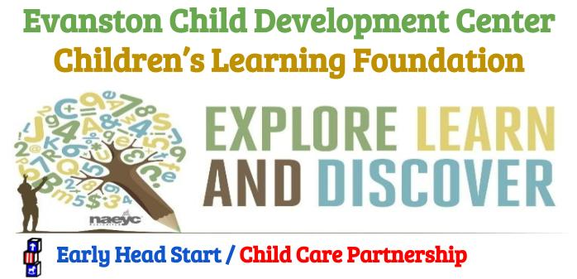

ANNUAL REPORT

2019
Email: info@ecdcwyo.org  Website: evanstonchilddevelpmentcenter.org | Tel: (307) 789-7040  336 Summit St, Evanston, WY 82930
Contents
Executive Summary 2
Enrollment/Recruitment 2
Family Services 2
Family Engagement 2
Community Partnership 2
Health Services 2
Financial 2
Revenue & Budget YE 6/31/2019 2
Independent Auditor’s Report 2

Executive Summary
The Evanston Child Development Center was established in 1981 as a community, nonprofit Early Care and Education Center. In 2009 we opened our new center in Bridger Valley-The Children’s Learning Foundation. We currently serve over 500 children in Uinta County, Wyoming. A Board of Directors governs our centers. The Board of Directors is responsible for the overall operation of the organization, compliance with all federal and state grant requirements, and the implementation of all regulations as described in The Evanston Development Center Bylaws. The Board ensures that the purposes of all our programs are being met and determines long-range financial and strategic goals to increase service levels.

The Evanston Child Development Center has been instrumental in Uinta County for over thirty years ensuring that young children have a greater chance of success by giving them the kind of early education and intervention that improves their language, cognitive and developmental skills, addressing developmental difficulties as early as possible.

On March 1st, 2015, we were awarded the Early Head Start/Child Care Partnership grant. We immediately began implementation of the program. We are funded for 72 EHS slots which are divided amongst our two centers. Initial goals included recruitment and enrollment, hiring teachers and staff, upgrading classrooms, training and establishing a policy council and governing board.

This annual report was developed through a collaborative effort with staff, governing board, and parent committees. The information is gathered from annual fiscal audits, federal and state reviews, and program information reports (PIR). This information is compiled to reflect the quality of early childcare programs offered to Uinta County, Wyoming, families from our centers in Evanston and Mountain View.

Enrollment/Recruitment
To reach children and families most in need of Early Head Start services and Pre-school TANF slots, a recruitment process that actively informs all families with eligible children within the Uinta County area of the availability of Early Head Start and our pre-school services is implemented. We solicit applications for as many eligible children as possible.

Cumulative Enrollment 2018-2019
Percentage of eligible Early Head Start-CCP children served  Based on 2019 Community Needs Assessment | 62%
Early Head Start-CCP Enrollment (0-3yr)  Total Number of children and families served | 112
Early Head Start Average Monthly Enrollment  Based on 2018-2019 program year | 72
Preschool (3-5yr)  Total number of children served | 120
School Age Enrichment (5-12yr)  Total number of children and families served | 60

Our Enrollment Specialist and Family Advocates work to recruit all children and families enrolled in the program are either income or categorically eligible for Early Head Start Services. We strive to enroll and maintain 72 qualified children age 0-3 years in the full day/full year program.

Early Head Start Cumulative Enrollment by Type of Eligibility
Income below 100% of the federal poverty line | 77
Receipt of public assistance – TANF/SSI | 2
Status as a foster child # children only | 4
Status as homeless | 9
Over-Income | 6
Over-Income 100% & 100% of the federal poverty guidelines | 14

Family Services

Family Engagement
Family who Received Family Services
Emergency Crisis Intervention | 21
Housing Assistance Referral | 16
Mental Health Referral | 5
English as a Second Language Training | 3
Adult Education | 16
Job Training | 10
Substance Abuse | 1
Domestic Violence | 0
Health Education | 9
Parenting Education | 15
Marriage Counseling/Education | 6
Our Family Advocates ensure that all Early Head Start families receive the resources they need for success through a family engagement approach. This approach involves conducting home visits, assessing family needs, developing a family action plan if needed, monthly family engagement activities, and educational events. This approach has encouraged our families to improve their lives economically, socially, and school readiness for children.

Community Partnership
Collaborative relationships with community partners assist us with meeting family needs and support assessed by our Family Advocates. These important relationships are initiated and maintained through our Health Advisory committee comprised of social service, health care, safety, and education agencies. We also take outreach steps in educating & recruiting civic groups, public schools, public libraries, and other social/religious organizations in the community.

Health Services
A comprehensive Health Services program is a cornerstone to success for children and families we serve. Collaborating, communicating, and educating families about the importance of healthy children by our Family Advocates and Community Partners has increased meeting the needs of low income families we serve.

Financial

Revenue & Budget YE 6/31/2019
Revenue | Amount | Non-Federal (InKind) | Amount
Private Pay | $250,00 | Personnel | $18,523
Employee Childcare | $35,000 | Travel | $0
WY Dep Family Svc Childcare Subsidy | $519,248 | Supplies | $2,500
Grants: |  | Rent | $130,819
Early Head Start-CCP | $957,730 | Other | $67,739
CACFP | $185,454 | Contractual | $30,852
21st Century Grant | $86,362
Uinta County Human Service Grant | $39,000
WY Dep. Work Force Service Grant | $57,000
Other Grants | $46,949
 | $2,174,794 |  | $240,433

Early Head Start-CCP Program Budget |  |  |  | Program Expenses
Budget Category | Program Operations | Training Technical Assistance | Total | Expense | Amount
Personnel | $661,408 | $15,000 | $676,409 | Personnel | $676,409
Fringe Benefits | $82,905 | $0 | $82,905 | Fringe Benefits | $82,905
Travel | $7,000 | $5,000 | $12,000 | Travel | $12,000
Supplies | $48,000 | $1,495 | $49,495 | Supplies | $49,495
Contractual | $38,000 | $300 | $38,300 | Contractual | $38,300
Other | $98,621 | $0 | $98,621 | Other | $98,621
 |  |  | $957,730 |  | $957,730

Independent Auditor’s Report
The financial statements for the year ending 8/31/2018: audited by Decoria-Maichel & Teague, P.S. The auditors disclosed no compliance findings material to the Organization’s financial statements.

